UNITED STATES

SECURITIES AND EXCHANGE COMMISSION
Washington, D.C. 20549

SCHEDULE 14A

PROXY STATEMENT PURSUANT TO SECTION 14(a) OF THE

SECURITIES EXCHANGE ACT OF 1934

Filed by the Registrant ☒ Filed by a Party other than the Registrant ☐

Check the appropriate box:

- Preliminary Proxy Statement

- Confidential, for Use of the Commission Only (as permitted by Rule 14a-6(e)(2))

- Definitive Proxy Statement

- Definitive Additional Materials

- Soliciting Material Pursuant to §240.14a-2

QUALYS, INC.

(Name of Registrant as Specified In Its Charter)

Payment of Filing Fee (Check the appropriate box):

- No fee required.

- Fee computed on table below per Exchange Act Rules 14a-6(i)(1) and 0-11.

  - Title of each class of securities to which transaction applies:

  - Aggregate number of securities to which transaction applies:

  - Per unit price or other underlying value of transaction computed pursuant to Exchange Act Rule 0-11 (set forth the amount on which the filing fee is calculated and state how it was determined):

  - Proposed maximum aggregate value of transaction:

  - Total fee paid:

- Fee paid previously with preliminary materials.

- Check box if any part of the fee is offset as provided by Exchange Act Rule 0-11(a)(2) and identify the filing for which the offsetting fee was paid previously. Identify the previous filing by registration statement number, or the Form or Schedule and the date of its filing.

  - Amount Previously Paid:

  - Form, Schedule or Registration Statement No.:

  - Filing Party:

  - Date Filed:

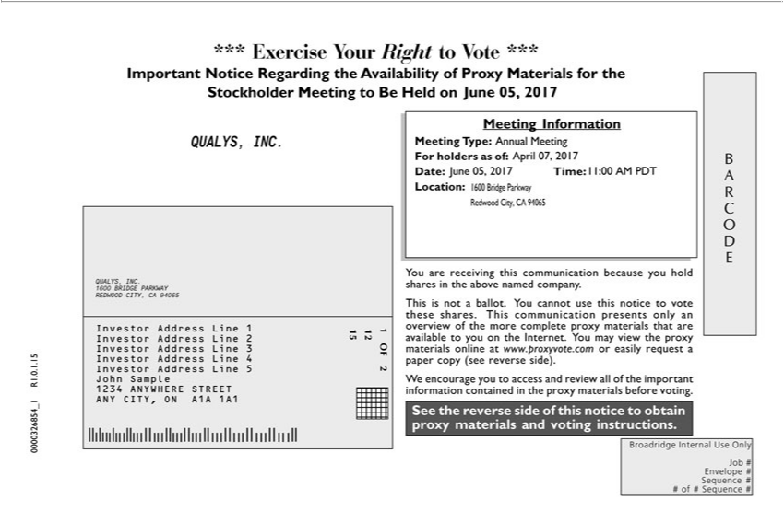

*** Exercise Your Right to Vote *** Important Notice Regarding the Availability of Proxy Materials for the Stockholder Meeting to Be Held on June 05, 2017 QUALYS, INC. Meeting Information Meeting
REDWOODType:Annual Meeting,CAFor94065holdersInveastorof:AddressApril07,Line2017InvestorDate:JuneAddress05,2017LineTime:2Investor11:00AddressAMPDTLineLocation:3Investor1600AddressBridgeLineParkway4InvestorRedwoodAddressCity,LineCA 94065JohnQUALYS,Sample1234INC.ANYWHERE1600BRIDGESTREETPARKWANYY CITY,

ON A1A 1A1CITYou are receiving this communication because you hold shares in the above named company. This is not ballot. You cannot use this notice to vote these shares. This communication presents materials onlyanoverviewofthemorecompleteproxymaterialsthatareavailabletoyoutheInternet.Youmayviewtheproxyonlineatwww.proxyvote.comoreasilyrequestapapercopy(seereverseside).We
encourage you to access and review all of the important information contained in the proxy materials before voting. See the reverse side of this notice to obtain proxy materials and voting instructions. BARCODE Broadridge Internal Use Only Job # Envelope # Sequence # # of # Sequence # 0000326854_1 R1.0.1.15

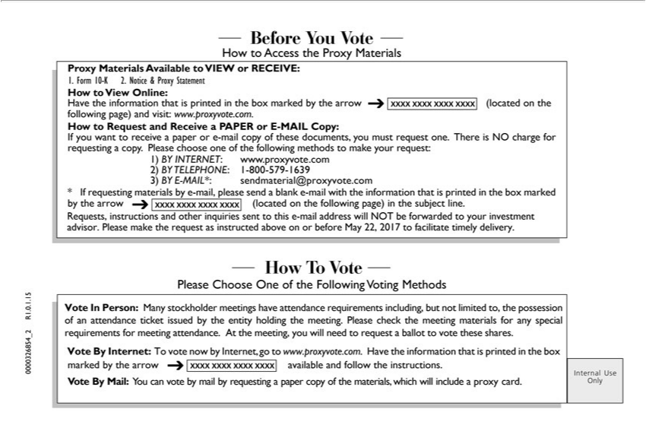

Before You Vote How to Access the Proxy Materials Proxy Materials Available to VIEW or RECEIVE: 1. Form 10-K 2. Notice & Proxy Statement How to View Online: Have the information that is printed in the box marked by the (located on the following page) and visit: www.proxyvote.com. How to Request and Receive a PAPER or E-MAIL Copy: If you want to receive a paper or e-mail copy of these documents,youmustrequestone.ThereisNOchargeforrequestingcopy.Pleasechooseoneofthefollowingmethodstomakeyourrequest:1)BYINTERNET:www.proxyvote.com2)BYTELEPHONE:1-800-579-1639 3) BY E-MAIL*: sendmaterial@proxyvote.com * If requesting materials addressby-mail, please sendforwardedblanke-mail with the informatadvisoron that is printed in the box marked by the (located on the following page)inthesubjectline.Requests,andotherinquiriessenttothis-mailwillNOTbetoyourinvestment.PleasemaketherequestasinstructedaboveonorbeforeMay22, instructions 2017tofacilitatetimelydelivery.HowTVotePleaseChooseOneoftheFollowingVotingMethodsVoteInPerson:Manystockholdermeetingshaveattendancerequirementsincluding,butnotlimitedto,the possession of an attendance ticket issued by the entity holding the meeting. Please check the meeting materials any special requirements for meeting attendance. At the meeting, you will need to request a
information
Mail:ballot Youtovotecanthesevote shares.bymailVotebyrequestingByInternet:apaperTovotecopynowof bytheInternet,materials,gowhichtowww.proxyvote.com.willincludeaproxyHavecard.the0000326854_2thatR1.0.1.15isprintedInternalintheUseboxOnlymarked by the available and follow the instructions. Vote By

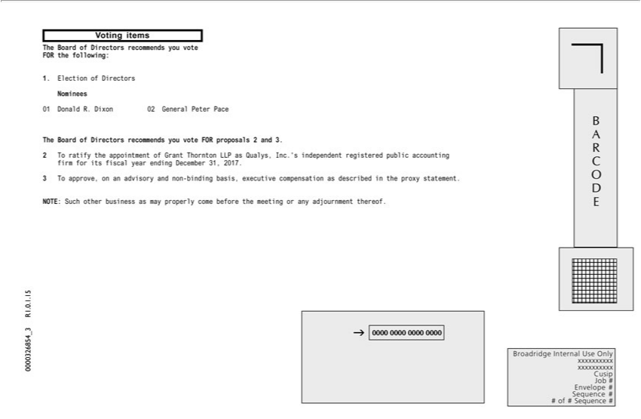

Voting items The _{Board} of Directors recommends you vote FOR the following: 1. Election of Directors Nominees 01 Donald R. Dixon 02 General Peter Pace The_{December}Board of Directors _{recommends} you vote FOR

proposals 2 and 3. 2 T ratify the appointment of Grant Thornton LLP as Qualys, Inc.’s independent registered public accounting firm for its fiscal year ending 31, 2017. 3 T approve, on an advisory and non-binding basis, executive compensation as described in the proxy statement. NOTE: Such other business as may properly come before the meeting or any adjournment thereof. BARCODE Broadridge Internal Use Only xxxxxxxxxx xxxxxxxxxx Cusip Job # Envelope # Sequence # # of # Sequence # 0000326854_3 R1.0.1.15

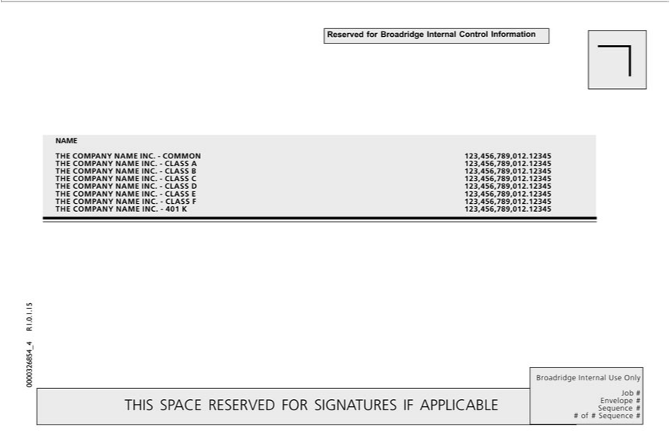

Reserved for Broadridge Internal Control Information NAME THE COMPANY NAME INC. – ^{CLASS}OMMON 123,456,789,012.12345 THE COMPANY NAME INC. - CLASS A 123,456,789,012.12345 THE
^{COMPANY NAME INC. - CLASS} B 123,456,789,012.12345 THE COMPANY NAME INC. - C 123,456,789,012.12345 THE COMPANY NAME INC. - CLASS D 123,456,789,012.12345 THE E 123,456,789,012.12345 THE COMPANY NAME INC.- CLASS F 123,456,789,012.12345 THE COMPANY NAME INC. - 401 K 123,456,789,012.12345

