UNITED STATES

SECURITIES AND EXCHANGE COMMISSION

Washington, D.C. 20549

SCHEDULE 14A

PROXY STATEMENT PURSUANT TO SECTION 14(a) OF THE SECURITIES

EXCHANGE ACT OF 1934 (AMENDMENT NO. )

Filed by the Registrant ☒

Filed by a Party other than the Registrant ☐

Check the appropriate box:

- Preliminary Proxy Statement

- Confidential, for Use of the Commission Only (as permitted by Rule 14a-6(e)(2))

- Definitive Proxy Statement

- Definitive Additional Materials

- Soliciting Material Pursuant to §240.14a-12

QUALYS, INC.

(Name of Registrant as Specified In Its Charter)

Payment of Filing Fee (Check the appropriate box):
- No fee required.

- Fee computed on table below per Exchange Act Rules 14a-6(i)(1) and 0-11.

  - Title of each class of securities to which transaction applies:

  - Aggregate number of securities to which transaction applies:

  - Per unit price or other underlying value of transaction computed pursuant to Exchange Act Rule 0-11 (set forth the amount on which the filing fee is calculated and state how it was determined):

  - Proposed maximum aggregate value of transaction:

  - Total fee paid:

- Fee paid previously with preliminary materials.

- Check box if any part of the fee is offset as provided by Exchange Act Rule 0-11(a)(2) and identify the filing for which the offsetting fee was paid previously. Identify the previous filing by registration statement number, or the Form or Schedule and the date of its filing.

- Amount Previously Paid:

- Form, Schedule or Registration Statement No.:

- Filing Party:

- Date Filed:

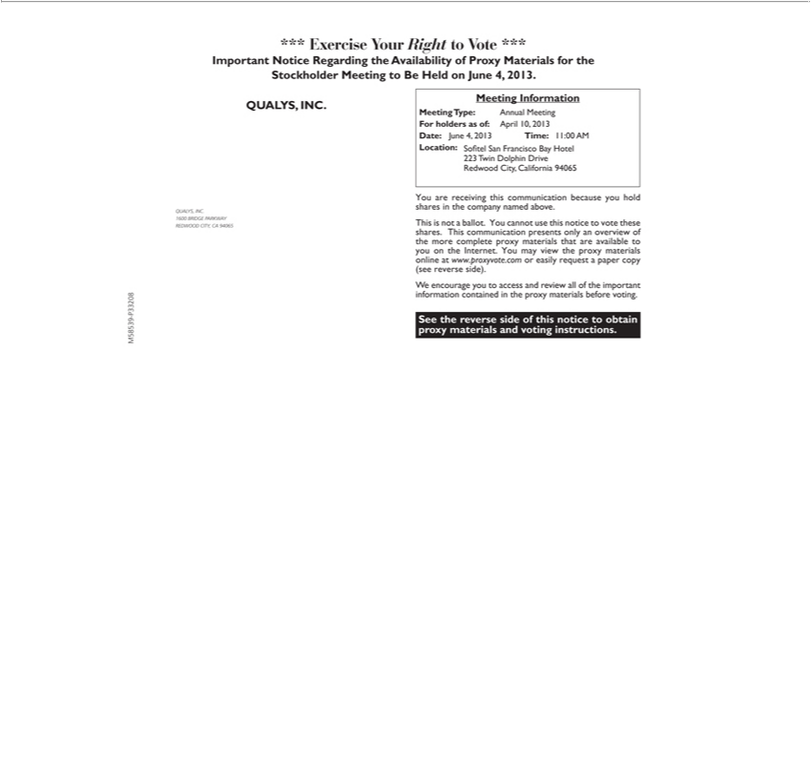

*** Exercise Your Right to Vote ***
MeetingImportantInformationNoticeRegarding the Availability of Proxy Materials for the Stockholder Meeting to Be Held on June 4, 2013.
QUALYS, INC.
1600REDWOODBRIDGECITY,PARKWAYCA94065
ForMeetingholdersType:as of:AnnualAprilMeeting^{10,}2013
Date: June 4, 2013 Time: 1:00 AM Location: Sofitel San Francisco Bay Hotel 223 Twin Dolphin Drive Redwood City, California 94065 You are receiving this communication because you hold shares in the company named above.

This is not a ballot. You cannot use this notice to vote these

shares. This communication presents only an overview of the more complete proxy materials that are available to you on the Internet. You may view the proxy materials online at www.proxyvote.com or easily _{requestencourage}paper copy (see reverse side).
W you to access and review all of the important information contained in the proxy materials before voting.
M58539-P33208
See the reverse side of this notice to obtain proxy materials and voting instructions.

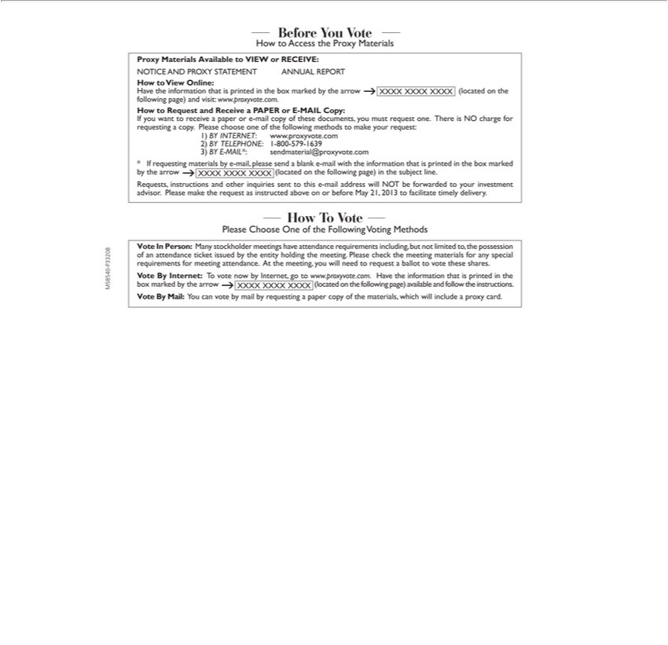

BeforeHowtoYouAccessVotethe Proxy Materials
Proxy Materials Available to VIEW or RECEIVE:
NOTICEavetoViewANDOnline:PROXY STATEMENT ANNUAL REPORT
the information that is printed in the box marked by the arrow XXXX XXXX XXXX (located on the following page) and visit: www.proxyvote.com.
IfHowyoutowantRequesttoreceiveandReceiveapaperaorPAPER-mailorcopyE-MAILoftheseCopy:documents, you must request one. There is NO charge for requesting a copy. Please choose one of the following methods to make your request:
*1)IfBYrequestingINTERNET:materialswwwby.proxyvote-mail,please.com2)sendBYaTELEPHONE:blanke-mailwith1-800the-579information-16393) BYthat Eis-MAIL*:printedinsendmaterial@proxyvote.comtheboxmarkedbythearrow XXXX XXXX XXXX (located on the following page) in the subject line.

Requests, instructions and other inquiries sent to this e-mail address will NOT be forwarded to your investment advisor. Please make the request as instructed above on or before May 21, 2013 to facilitate timely delivery.
Please Choose One of the Following Voting Methods

Vote In Person: Many stockholder meetings have attendance requirements including, but not limited to, the possession of an attendance ticket issued by the entity holding the meeting. Please check the meeting materials for any special requirements for meeting attendance. At the meeting, you will need to request a ballot to vote these shares.
Vote By Internet:_{instructions}Tvote now by Internet, go to www.proxyvote.com. Have the information that is printed in the box marked by the arrow XXXX XXXX XXXX (located on the following page) available and
follow the .
Vote By Mail: You can vote by mail by requesting a paper copy of the materials, which will include a proxy card.
M58540-P33208

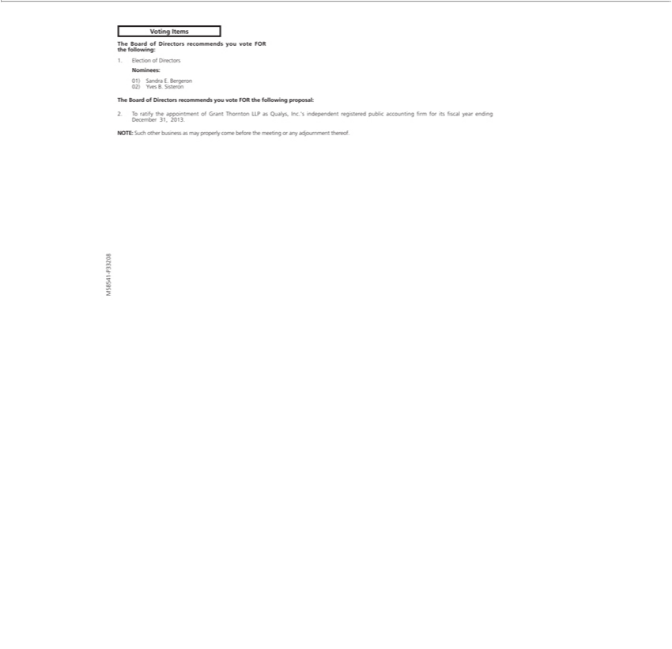

Voting Items
The Board of Directors recommends you vote FOR the following:
Nominees:1.Election of Directors
01) Sandra E. Bergeron 02) Yves B. Sisteron
The Board of Directors recommends you vote FOR the following _{proposal:}
^{NOTE:}
2. o ratifySuchtheotherappointmentbusiness asof mayGrantproperlyThorntoncomeLLPbeforeasQualys,themeetingInc.’independentoranyadjournmentregisteredthereof.public accounting from for its fiscal year ending December 31, 2013.

M58541-P33208



M58542-P33208

